**Data Based Modeling:**

**Noun List:**

| **No.** | **Noun** | **P / S** | **Attributes** |
| --- | --- | --- | --- |
| 1 | ISRT | P |  |
| 2 | Faculty | P |  |
| 3 | Book | P |  |
| 4 | Research Journal | P |  |
| 5 | Demand | P |  |
| 6 | Suggestion | P |  |
| 7 | Category | P |  |
| 8 | Annual budget | P |  |
| 9 | Bill | P |  |
| 10 | Accountability | P |  |
| 11 | Borrowing history | P |  |
| 12 | Internal reference | P |  |
| 13 | Researcher | P |  |
| 14 | Research | P |  |
| 15 | Output | P |  |
| 16 | Certificate | P |  |
| 17 | Clearance | P |  |
| 18 | Marksheet | P |  |
| 19 | Pension | P |  |
| 20 | Pending book | P |  |
| 21 | Statement | P |  |
| 22 | Mobile | P |  |
| 23 | Working duration | P |  |
| 24 | Metadata | P |  |
| 25 | Audit | P |  |
| 26 | Academic publishing | P |  |
| 27 | Account | P |  |
| 28 | Library Management System (LMS) | S |  |
| 29 | User | S | 34, 35, 42, 43, 45, 46, 76 |
| 30 | Student | S | 38, 39, 40, 41 |
| 31 | Teacher | S | 44, 101 |
| 32 | Staff | S | 44, 101 |
| 33 | Faculty | S |  |
| 34 | Name | S |  |
| 35 | Phone number | S |  |
| 36 | OTP | S |  |
| 37 | Verification | S |  |
| 38 | Roll number | S |  |
| 39 | Registration number | S |  |
| 40 | Session | S |  |
| 41 | Hall name | S |  |
| 42 | Email | S |  |
| 43 | Address | S |  |
| 44 | Designation | S |  |
| 45 | User ID | S |  |
| 46 | Password | S |  |
| 47 | Account | S |  |
| 48 | Due date | S |  |
| 49 | Fine | S | 87, 103 |
| 50 | Payment | S | 35, 85,104 |
| 51 | Status | S |  |
| 52 | Notification | S |  |
| 53 | SMS | S |  |
| 54 | E-Library | S |  |
| 55 | Book PDF | S |  |
| 56 | Title | S |  |
| 57 | Author | S |  |
| 58 | Subject | S |  |
| 59 | Summary PDF | S |  |
| 60 | Review | S |  |
| 61 | Rating | S |  |
| 62 | Feedback | S |  |
| 63 | Smart search function | S |  |
| 64 | Filtering option | S |  |
| 65 | Borrowing request | S |  |
| 66 | Borrowing form | S |  |
| 67 | Classification number | S |  |
| 68 | Integrated library catalog | S |  |
| 69 | Book information | S |  |
| 70 | Availability | S |  |
| 71 | Waitlist | S |  |
| 72 | Eligibility | S |  |
| 73 | Approval | S |  |
| 74 | Real-time stock | S |  |
| 75 | Queue | S |  |
| 76 | Role | S |  |
| 77 | Application time | S |  |
| 78 | Teacher priority | S |  |
| 79 | Category | S |  |
| 80 | Return deadline | S |  |
| 81 | Fine policy | S |  |
| 82 | Library seal | S |  |
| 83 | Blacklist status | S |  |
| 84 | Cancellation notice | S |  |
| 85 | Mobile Financial Services (bKash, Nagad) | S |  |
| 86 | Transaction confirmation | S |  |
| 87 | Demerit point | S |  |
| 88 | Outstanding fine | S |  |
| 89 | Reactivation | S |  |
| 90 | Renewal | S |  |
| 91 | Borrowing record | S |  |
| 92 | Book purchase committee | S |  |
| 93 | Clearance | S | 51,83, 94, 95, 96, 97, 98, 99,100 |
| 94 | Request | S |  |
| 95 | Type | S |  |
| 96 | Form | S |  |
| 97 | Certificate | S |  |
| 98 | Marksheet | S |  |
| 99 | Pension | S |  |
| 100 | Pending book | S |  |
| 101 | Department | S |  |
| 102 | Book | S | 55, 56, 57, 58, 59, 67, 69, |
| 103 | Amount | S |  |
| 104 | Transaction ID | S |  |

**Data Objects:**

| No. | Data Objects | Attributes |
| --- | --- | --- |
| 1 | User | Name, Phone no, Email, Address, User Id, Password, Role, Demerit Point, Amount |
| 2 | Student | Roll no, Registration no, Session, Hall |
| 3 | Teacher | Designation, Department |
| 4 | Staff | Designation, Department |
| 5 | Clearance | Status, Blacklist Status, Request, Type, Form, Certificate, Marksheet, Pension |
| 6 | Book | Book pdf, Title, Author, Subject, Classification no, Category, Rating, Archive |
| 7 | Payment | Phone no, MFS, Transaction ID |
| 8 | OTP | OTP no, Phone no, Time, Date |
| 9 | Borrowing_Details | Borrow Id, Borrow Date, Return date, Pending Status, Return Status |
| 10 | Application | Application ID, Status |

**Relations:**

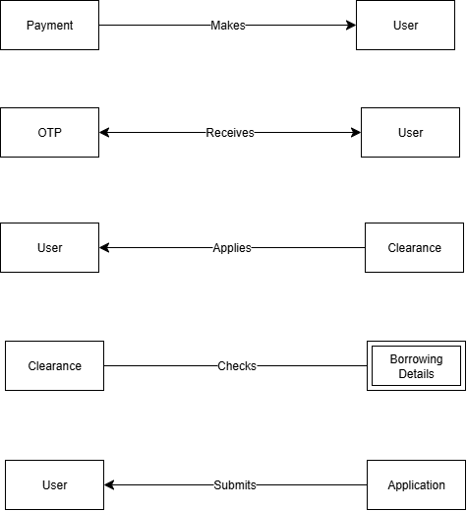

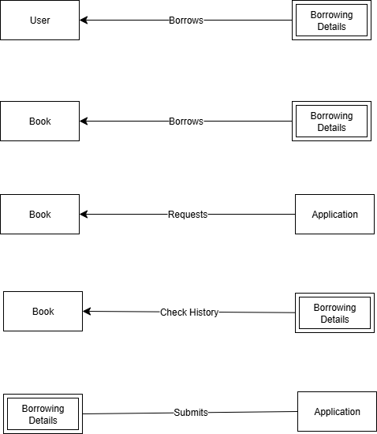

**ERD:**

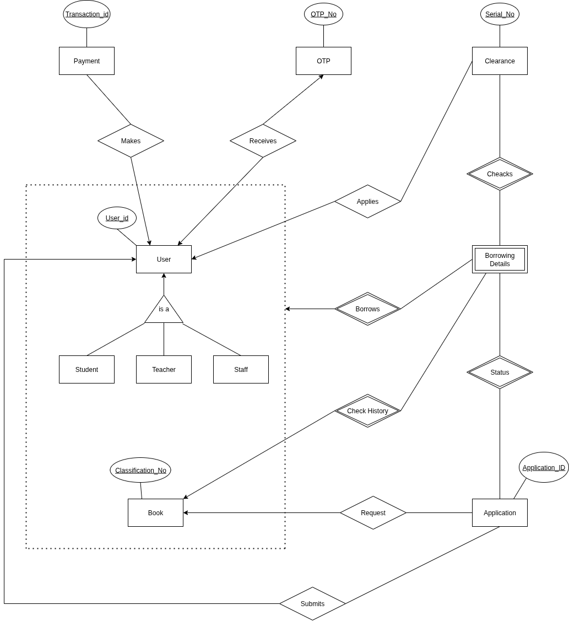

**Schema:**

| **No.** | **Entity Name** | **Attribute** | **Description** |
| --- | --- | --- | --- |
| 1. | User | User_Id (PK) | Unique identifier for each user |
| Name | Full name of the user |
| Phone_No | User’s phone number |
| Email | User’s email address |
| Address | Residential address |
| Password | Login password |
| Role | Defines user type (Student, Teacher, Staff) |
| Demerit_Point | Points deducted for violations |
| Amount | Balance amount or dues |
| 2. | Student | User_Id (PK, FK) | References User |
| Roll_No | Student roll number |
| Registration_No | Student registration number |
| Session | Academic session |
| Hall | Hall or dormitory name |
| 3. | Teacher | User_Id (PK, FK) | References User |
| Designation | Teacher’s designation |
| Department | Department of the teacher |
| 4. | Staff | User_Id (PK, FK) | References User |
| Designation | Staff designation |
| Department | Staff department |
| 5. | Cleareance | Serial_No (PK) | Unique clearance number |
| User_Id (FK) | References User |
| Status | Clearance status |
| Blacklist_Status | Whether the user is blacklisted |
| Request | Clearance request type |
| Type | Type of clearance |
| Form | Clearance form |
| Certificate | Related certificate |
| Marksheet | Related marksheet |
| Pension | Pension details if applicable |
| 6. | Book | Classification_No (PK) | Unique classification number |
| Title | Book title |
| Author | Book author |
| Subject | Subject area |
| Book_PDF | PDF file path or link |
| Category | Book category |
| Rating | Book rating |
| Archive | Whether book is archived |
| 7. | Payment | Transaction_Id (PK) | Unique transaction identifier |
| User_Id (FK) | References User |
| Phone_No | Payment phone number |
| MFS | Mobile financial service used |
| 8. | OTP | OTP_No (PK) | One-time password identifier |
| User_Id (FK) | References User |
| Phone_No | User’s phone number |
| Time | OTP generation time |
| Date | OTP generation date |
| 9. | Borrowing_Details | Borrow_Id (PK) | Unique borrow identifier |
| User_Id (FK) | References User |
| Classification_No (FK) | References Book |
| Borrow_Date | Borrowing date |
| Return_Date | Book return date |
| Pending_Status | Whether the book is pending return |
| Return_Status | Status of return (Returned/Pending) |
| 10. | Application | Application_ID (PK) | Unique application identifier |
| User_Id (FK) | References User |
| Status | Application status |